BRITISH SOCIETY FOR THE PROPAGATION OF THE GOSPEL AMONG THE JEWS

(today known as ‘Christian Witness to Israel’)

THE
FIRST REPORT
OF THE
PUBLIC MEETING OF THE SOCIETY
April 24th 1843

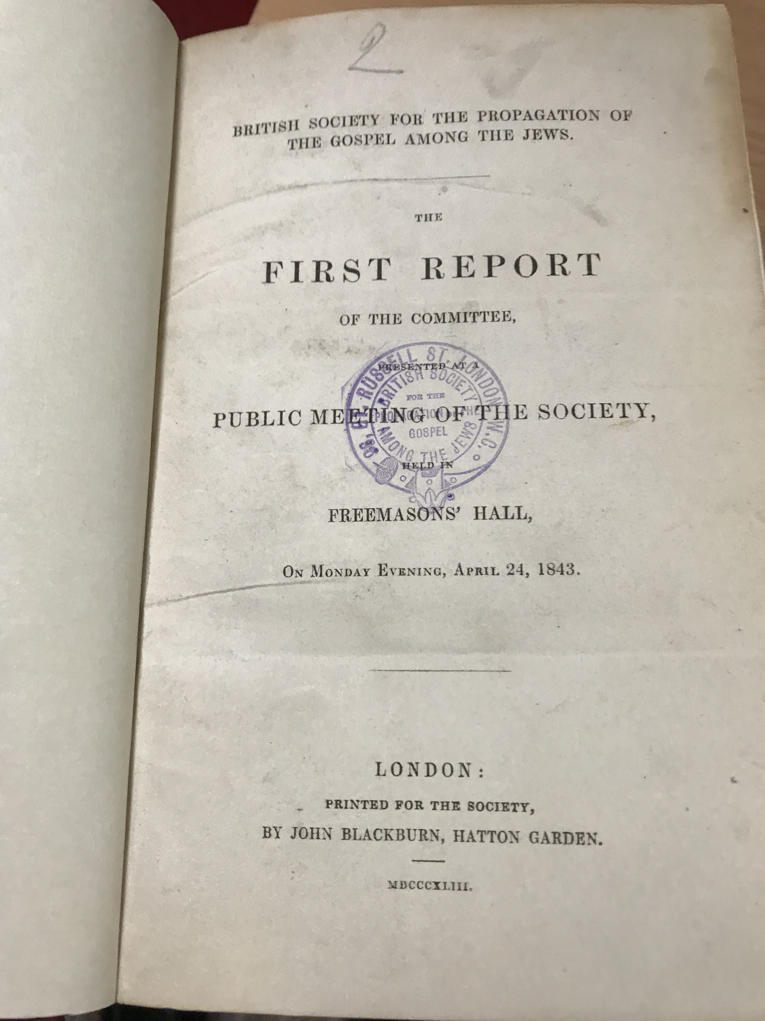
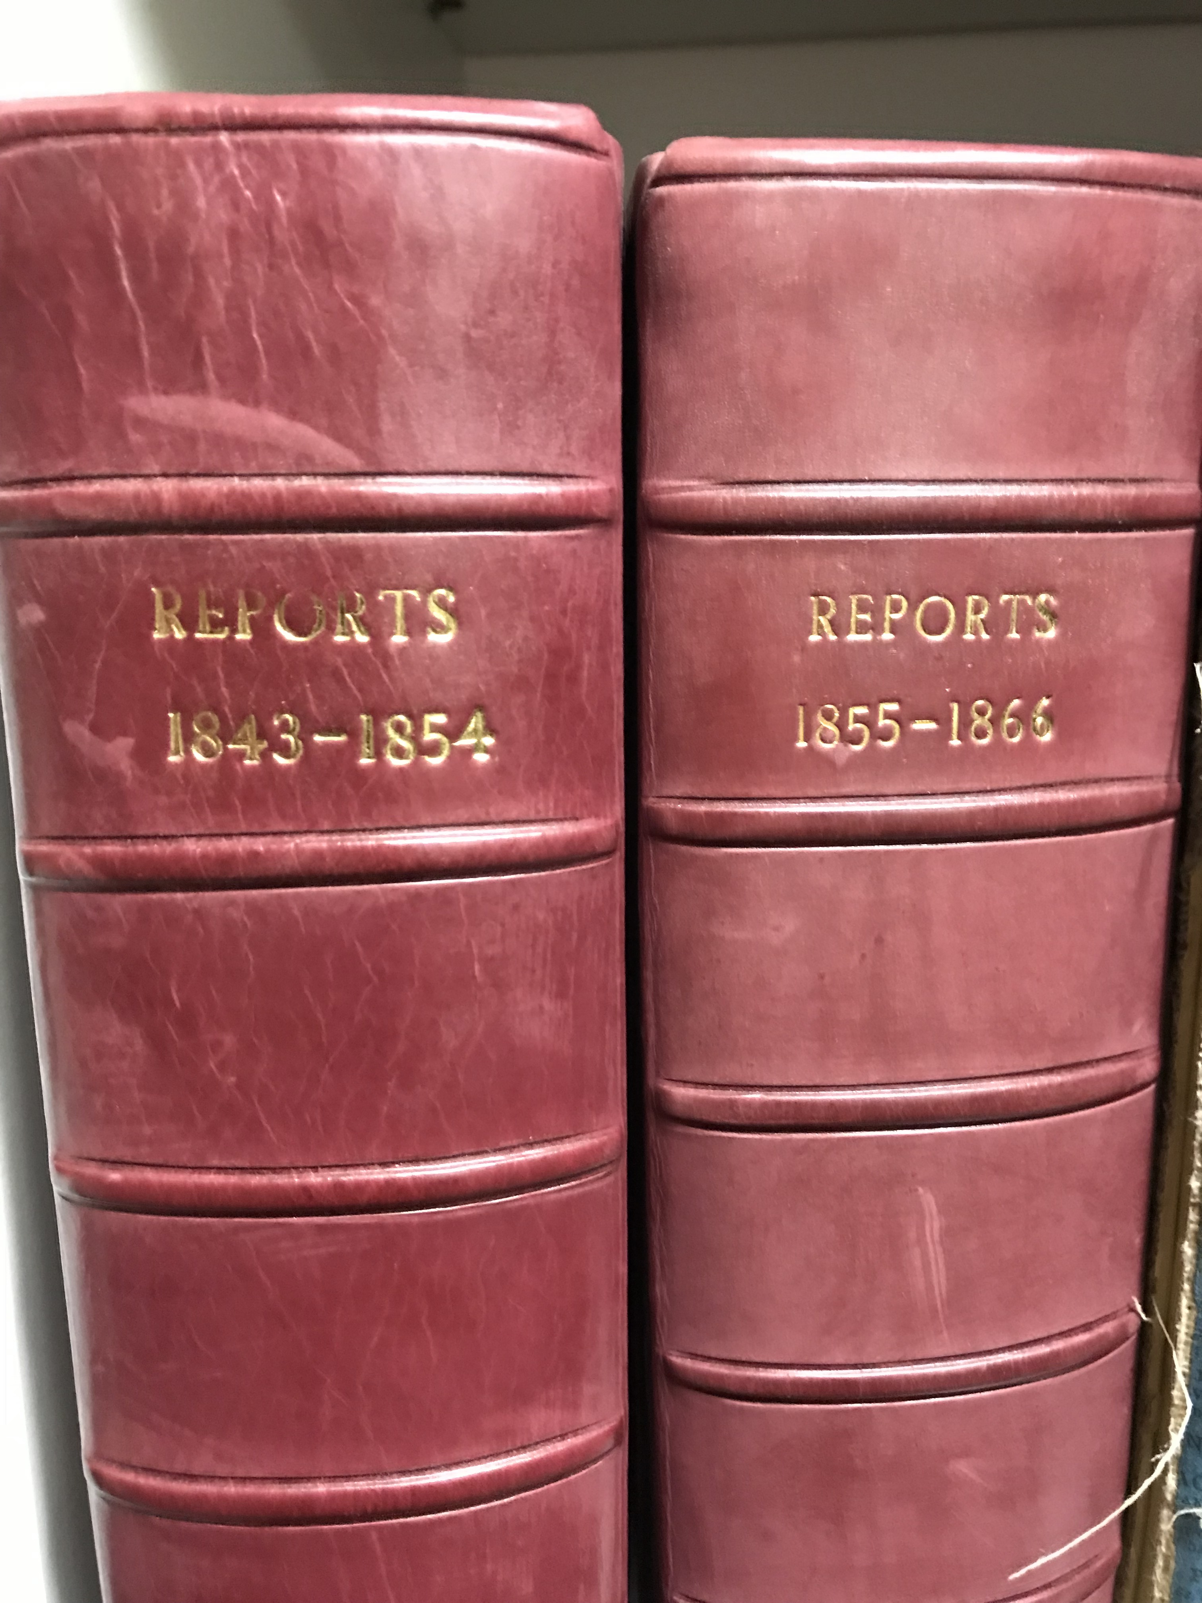
At the First
PUBLIC MEETING OF THE SOCIETY
Held at Freemasons’ Hall
On Monday Evening, April 24, 1843

John Dean Paul, Esq. in the Chair. The Rev J A Miller opened the Meeting by prayer.

The Rev Dr Henderson read the Report of the Committee: after which, on a motion by the Rev Dr Burder, seconded by the Rev Robert Redpath.
IT WAS RESOLVED,
That the Report now read be adopted, and that it be printed under the direction of the committee.

On a motion by the Rev John Blackburn, seconded by the Rev George Scott,
IT WAS RESOLVED,
That, while this Meeting deeply sympathizes with the Jewish people in the unparalleled sufferings to which, in consequence of their rejection of the Messiah, they have been subjected, it joyfully contemplates, in the predictions of Holy Writ, and in the signs of the time, the approach of a brighter period in their history, when, cordially receiving Him as their Saviour and King, they shall richly participate in the blessings of redemption.

On a motion by the Rev Thomas Archer, seconded by the Rev J Hamilton
IT WAS RESOLVED
That this Meeting regards it to be the special and solemn duty of all Christians, who have not hitherto engaged in scriptural efforts for promoting the spiritual welfare of Israel, strenuously to co-operate for the attainment of this important object.

On a motion by the Rev Robert Ferguson, seconded by the Rev Dr Cox.
IT WAS RESOLVED,
That the thanks of this Meeting be given to the Committee, the Treasurer, and the Secretaries, for their services in forming this Society, and conducting its affairs to the present time; that John Dean Paul, Esq, be the Treasurer; that the Rev Dr Henderson, and the Rev James Hamilton, be the Honorary Secretaries; and Mr George Yonge be the Acting Secretary; and that the following Ministers and Gentleman (See Page 5) be the Committee for the ensuing year, with power to fill up vacancies.

On a motion by the Rev William Bunting, seconded by William Hamilton, Esq.
IT WAS RESOLVED,
That the thanks of the meeting be presented to the Ministers who have taken part in the Course of Lectures on the subject of the Jews, recently delivered at the request of the committee.

On a motion by the Rev J C Burns, seconded by Dr Stewart,
IT WAS RESOLVED,
That the cordial thanks of this Meeting be presented to John Dean Paul, Esq, for his kindness in presiding over the business of the evening.
REPORT

Whatever conclusions may be drawn from it, the fact is indisputable, that the Jewish people have attracted more Christian attention within the past few years, than at any period of their history since the days of the Apostles. Instead of being the mere by-word and proverb which, for ages, they had remained, they have become the subject of intellectual study, as well as of pious and philanthropic solicitude. The past history, and, still more, the future prospects, of the nation, have originated a voluminous authorship. Their social and civil condition has been a topic of earnest consideration with the legislators and statesmen of our own and other countries. Scarcely a season has elapsed without having originated a course of public lectures on their scriptural distinctions, prerogatives, and spiritual claims. Both in Europe and America, various Societies have arisen, which have for their object the advancement of the spiritual good of Israel. And, if favour shown to the dust of Zion be regarded as the token that the "set time,” when the Lord will arise and have mercy upon her, is come, it may warrantably be inferred that this period is now near at hand.

Among these Institutions, the London Society for Promoting Christianity among the Jews, originated by the efforts which, for a number of years, the London Missionary Society combined with its foreign labours among the heathen, has long been carrying on its operations in many of those regions of Europe and Asia where the Jews abound, and where they are accessible by Christian missionaries. By this institution, much has been done for the lost sheep of the house of Israel, in the way of printing and distributing tracts, circulating the Hebrew Scriptures, and educating Jewish youth, as well as in the more direct labours of its numerous evangelists. Although, from its constitution, it is entirely administered by the members of one communion, - a circumstance which renders a more comprehensive association desirable, - yet, in its own large and important field of labour, we would bid God speed to its every scriptural effort.

Five years ago, the General Assembly of the Church of Scotland turned its attention to the cause of Israel. One of its first movements was to send a deputation of four ministers to visit Palestine, and other countries in which the Jews reside, or to which they resort. On its return, the deputation reported many stations where they believed a great and effectual door was open; and the General Assembly at once occupied two, - Pesth and Jassy, - where their missionaries are now engaged in zealous and devoted labours among the posterity of Abraham. It has since sent out a missionary to Palestine, to carry on similar labours there.

For a considerable time it had been a subject of deep regret with many ministers and members of churches in this metropolis, and in the country, that no Society existed in which the friends of Israel, belonging to all evangelical communions, might find an outlet for their liberality, and a rallying-point for their labours and prayers, on behalf of that interesting people. After repeated meetings and much earnest conference, and having been encouraged by overtures of co-operation from the General Assembly’s Jewish Committee, a number of ministers and others, convened by circular, on the 7th of November, 1842, formed themselves into an Association, of which the following are the fundamental principles, as expressed in the resolutions unanimously adopted on the occasion”-

I – That a society be formed, to be called THE BRITISH SOCIETY FOR THE PROPAGATION OF THE GOSPEL AMONG THE JEWS.
II – That the Society consist of Christians of evangelical principles, interested in the propagation of the Gospel among the Jews.
III – That the more immediate field of the Society’s operations be London, and the larger towns of the United Kingdom.
IV – That the Society shall maintain a friendly correspondence and co-operation with the Church of Scotland’s Mission to the Jews.
V – That the Association cordially invite the co-operation of all kindred institutions.
VI – That an Annual Subscription of Ten Shillings constitute Membership; and a Donation of Five Pounds, Membership for life.
VII That the Committee consist of twenty-four Ministers, and an equal number of Laymen; and that the Treasurer and Secretaries be members ex officiis.

Though, agreeably to the terms of the third of these Resolututions, the more immediate sphere of the Society’s operations is London, and the larger towns in the United Kingdom, yet the Committee cherish the hope, that the countenance and support which they shall receive from the Christian public will, ere long, enable them to extend their labours into foreign parts, whither the Sons of Jacob have been scattered in the dark and cloudy day of the Lord’s anger.
The Society, thus formed, has but scarcely entered upon its labours. In order more extensively to awaken the interest of the followers of the Redeemer, the Committee first of all resolved that a series of Lectures should be preached, bearing upon the history, condition and prospects of the Jews. These Lectures have been delivered in the National Scotch Church, Regent Square, on the evening of each successive Friday, during the Spring quarter, now ending; and the interested, and often crowded, auditories which frequented them, assure the Committee, that the object has been effectually gained.
As an exemplification of the principles upon which the Society is based, and as an earnest of the spirit in which it is ardently hoped that its labours will hereafter be conducted, it may be proper here to mention the names of the Lecturers, representing the Presbyterian, Congregational, Wesleyan and Baptist bodies.
REV J PYE SMITH, DD, FRS; REV JAMES HAMILTON, AM; REV F A COX, DD, LLD; REV T ARCHER, AM; REV J BENNETT, DD; REV E HENDERSON, DD; REV J C BURNS, AM; REV H F BUNDER, DD; REV J MORISON, DD; REV J S STAMP; REV J HARRIS, DD.

One of the most zealous members of the Society, the Rev R Herschell – himself of the seed of Abraham – was prevented from delivering the Lecture assigned to him, in consequence of his having been unexpectedly invited to proceed on a visit to the land of his fathers; but the Committee expect that he will be able to deliver it after his return, and to furnish much interesting information, as well as to suggest many valuable hints relative to his brethren according to the flesh.
It has already been stated, that, at the outset, the Society placed itself on a footing of friendly alliance with the Church of Scotland’s Jewish Committee; and they have the farther gratification to report, that the said Committee have confirmed the brotherly covenant by a vote of £500 in aid of the funds of this Society.

The Committee have already adopted such initiatory measures as lay in their power, for drawing the attention of the Jews in the metropolis to the things which belong to their everlasting peace; and should this Meeting, by publicly sanctioning the formation of the Society, authorize them to proceed in their labours, they intend to take immediate steps for carrying out its objects, by employing suitable agents, and opening a correspondence for the purpose of ascertaining the state of the Jews, and exciting a greater degree of interest on their behalf in the principal towns of the kingdom. They have also in contemplation measures for translating and publishing appropriate tracts and books in languages spoken by the dispersed of Israel.

In conclusion, the Committee hope much from the Christian people of England. This hope is strengthened by the signs of the times. But they desire chiefly to place their hope in Him who hath promised to the church life from the dead in Israel’s salvation. Trusting in his unchangeable faithfulness, and his everlasting love for the posterity of Abraham his friend, they would cordially unite in the prayer, -“Establish thou the work of our hands upon us; yea, the work of our hands establish thou it.”

TREASURER
JOHN DEAN PAUL

HONORARY SECRETARIES
REV E HENDERSON, DD
REV JAMES HAMILTON, AM

ACTING SECRETARY
MR GEORGE YONGE

COMMITTEE
CLERGY
Archer, Rev T, AM
Blackburn, Rev J
Bunting, Rev WM
Burder, Rev HF, DD
Burns, Rev JC, AM
Cox, Rev FA, DD
Cumming, Rev J, AM
Fletcher, Rev J, DD
Herschell, Rev R
Lorimer, Rev P, AM
Lyon, Rev WP, AB
Miller, Rev JA
Morison, Ref J, DD
Redpath, Rev R, AM
Thompson, Rev WM, AM
Yonge, Rev WC
LAYMEN
Cotes, Mr N
Ellis, Mr S
Fraser, Mr J
Gillespie, Mr A
Hamilton, Mr W
Law, Mr J
Lloyd, Mr W F
Moginie, Mr J
Smith, Sir Culling Eardley, Bart
Stewart, AP, MD
Swaine, Mr E
Wilson, Mr J
Wollaston, Mr FL

Donations and subscriptions received by the Treasurer, 217, Strand; the Secretaries; Messrs Nisbet and Co, 21 Berners Street; Mr Coates, 139, Cheapside and at the office of the Society 1 Crescent Place, New Bridge Street, Blackfriars between the hours of eleven and three.

-----------------------------------------------------------------------------------------------------------------------------

In thankful recognition of, and adherence to the founding principles of our missionary society, we reprint this in our 175th year to stir future generations to a similar burden for Jewish mission.

Further information: Christian Witness to Israel (N America), 6401 S. 50th St, Rogers AR 72758
www.cwina.org www.facebook.com/cwina cwinamerica@gmail.com

